# 

# Carry1st Marketing Analyst Technical Assessment

This marketing analytics assessment has been broken down into the following sections to test the applicant’s basic technical skills that is required for this role:

1. SQL Assessment
2. Marketing Analytics

* For the SQL questions you can make use of any Syntax. Please provide code in a document.
* For the Marketing Analytics, please provide output including code and analysis in a document(s). You should also prepare a short presentation to provide your recommendations.

## SQL Assessment

1. Using the following ERD which contains authors and episodes write a query to show for each author:  
   * The number of episodes they wrote.  
   * Their earliest episode date.  
   * Their latest episode date.  
     
   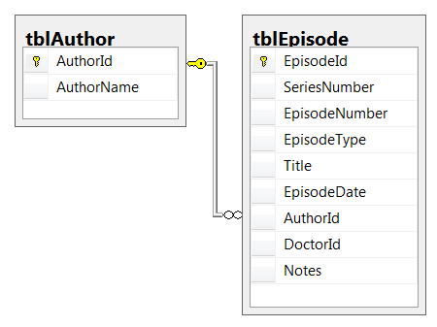
2. Using the following ERD which contains authors, doctors and episodes write a query to list out for each author and doctor the number of episodes made, but restrict your output to show only the author/doctor combinations for which more than 5 episodes have been written.

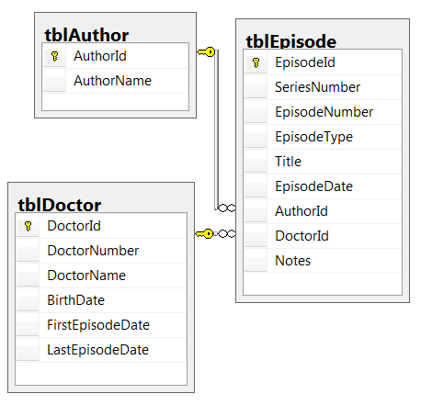

1. Using the following ERD write a query to list out for each episode year and enemy the number of episodes made, but in addition:
   1. Only show episodes made by doctors born before 1970; and
   2. Omit rows where an enemy appeared in only one episode in a particular year.

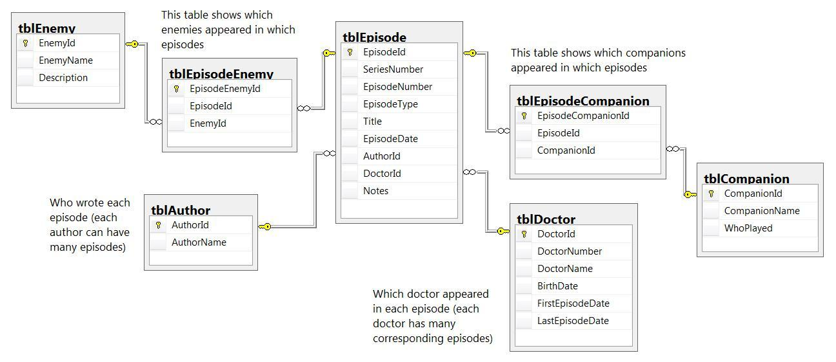

Answer:

1. Given the following tables make use of any SQL syntax and write a script to create new tables with the same structure, but they need to be partitioned on an appropriate column where applicable to ensure that reads taking place on these tables are more performant.  
   *Note: It is not required to cater for Foreign Keys as part of your create scripts.*

**tblTransaction**

* Transaction_ID (BIGINT)
* Amount (DOUBLE)
* Status (VARCHAR)
* Customer_ID (BIGINT)
* Created Date (TIMESTAMP)

**tblCustomer**

* Customer_ID (BIGINT)
* First Name (VARCHAR)
* Last Name (VARCHAR)
* Country_ID (BIGINT)
* Registration Date (TIMESTAMP)

**tblCountry**

* Country_ID (BIGINT)
* Full Name (VARCHAR)
* Code (VARCHAR)

1. Given the following table:

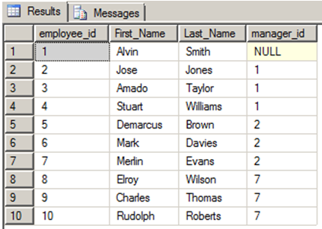

Create a query to display the hierarchical relationship between a certain employee and his direct and indirect managers.  
For example, for employee number 7, the query should return a result set where *Merlin* reports to *Jose*, and *Jose* reports to *Alvin*.

## Marketing Analytics Assessment Historic Performance Review and Strategic Roadmap for UA Improvement

**Objective:** To conduct a comprehensive analysis of historical performance data for 'SAMPLE PRODUCT' to identify key trends, effectiveness of user acquisition (UA) channels, and revenue generation patterns. The analysis should help create a strategic roadmap for optimizing future UA efforts and improving overall game monetization.

**Data Overview:** You will be analyzing data that includes fields such as Product Name, Month, Platform, Network, Country, UA Spend, Impressions, Clicks, Installs, Ad Revenue (non-cohorted and cohorted from D1 to D30), IAP Revenue (non-cohorted and cohorted from D1 to D30), and user retention metrics (D1, D7, D30).

**Data Dictionary:** Can be found in the tab “Data Dictionary”.

**Data:** [Sample Data.xlsx](https://docs.google.com/spreadsheets/d/1fgcHC254B7wH6P3BE3K9urMl35_NgIEm/edit?usp=sharing&ouid=104137670625063917540&rtpof=true&sd=true)

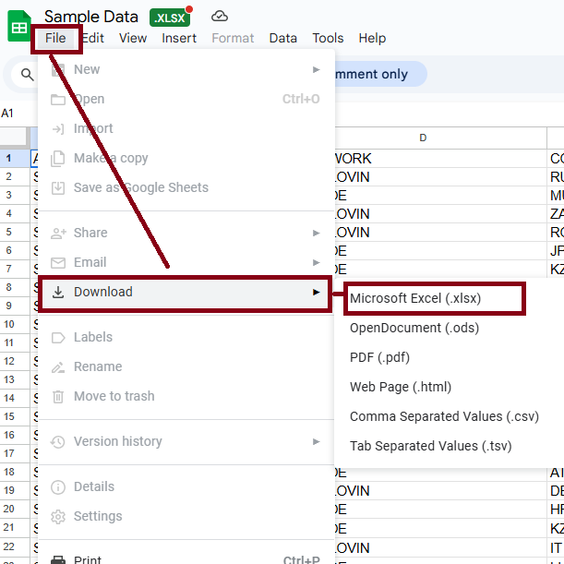

**Expected Deliverables:**

* A detailed analytical report including visuals and main findings
* Please also include your code
* A presentation deck ready for executive review (15 mins). Present your recommendations (2-3) with supporting analysis.
  + - 1. **Dashboard Summary**
      2. **Revenue generation analysis**
      3. **Revenue Retention**
      4. **User acquisition Funnel**
      5. **UA**
      6. **UA**
      7. **Network Analysi**
      8. **Country Analysis**
      9. **Retentation Heat map**